Intelligent Traffic Lights

Chaitanya Chembolu, Kautuk Desai, koundiniya Nouduri

Department of Computer Science and Engineering, SUNY Buffalo

# Abstract

Traffic signal systems have been employed since the early twentieth century. Since then, many different signal systems have been implemented to minimize the waiting time and most importantly deadly accidents at dangerous road intersections, streets on which schools are located and bad curves. Optimizing the traffic systems in real-time based on the vehicle flow and adapting accordingly is a challenging problem; mainly because as the size of the road increases there is a continuous increase of traffic congestion. This in-turn increases the total travel time and ultimately cost of travel. This project aims to address the issue and implement a method which can effectively reduce travel time, and thus, the cost of travel.

# Introduction

The current state of traffic signal ecosystem comprises of variety of different control systems ranging from clockwork mechanism to computerized control that self-adjust to minimize delay to people using the road. This project falls under the category of computerized control. With the advancement in computer vision the computerized control can be given the ability to see and analyze traffic to self-adjust based on the traffic at a particular signal. When waiting for a traffic light, the driver loses time and the car uses fuel. Hence, reducing waiting times can save society billions of dollars annually. Here is small fact to support the statement, based on the review and research, if travel time is reduced by 30-40% then the travel costs reduces by 15-20%. This is for one vehicle, so collectively 253 million cars and trucks on U.S. roads could easily save billions of dollars.[1]

Local time based signal controllers are among the most fundamental traffic signal system component. This often results in delay at red lights, when we have to wait while no one is using the green. Traffic signal control is an important practical problem. A recent study in the USA indicates that travel delays due to traffic congestion caused drivers to waste more than 3 billion gallons of fuel and kept travelers stuck in their cars for nearly 7 billion extra hours – 42 hours per rush-hour commuter. The total nationwide wasted money amounts to $160 billion, or $960 per commuter.[2] Moreover, since this wasted fuel and time leads directly to the percentage of time drivers spend in traffic; there are additional negative impacts on environmental conditions. The problem is so bad that most intensive exposure to air pollution happens at traffic junctions. It is mainly due to the ‘stop and go’ nature of the traffic flow. This severely affects the health of the people which may also lead to major respiratory problems. With the invention of computers, traffic lights started to become computerized. We all remember those days when a man stands at the center of a junction and controlling traffic at that junction. Since humans have the capability of looking and understanding the traffic issue this was probably the best implementation to control traffic. But, Over time computers improved, and the traffic lights subsequently improved, and they could now monitor traffic and change lights accordingly. Based on the software, the traffic of a city could now be predicted and accordingly controlled.

But the computerized approach still does not provide the human power of looking at the traffic, analyzing and acting accordingly. Our project aims to provide a simple approach to resolve unnecessary waiting time at traffic signal by providing vision to traffic system and an algorithm that can effectively control traffic.

# Related Work

While there has been a lot of work in the areas of vehicle detection using computer vision techniques, successful implementations of these algorithms in real time problems like traffic control, speeding detection etc. is still very limited. On exploration, we’ve come across vehicle detection using Haar Cascades, Background Subtraction(BGS) etc. This paper explores the potential of automating traffic control by building an algorithm using the aforementioned methods.

# Traffic signal control algorithm

The control problem is at a single intersection and the objective is to make the best local decisions possible, given the information that is locally available. The adaptive methods for optimization, based on dynamic programming, have been used for controlling a single intersection.[3]

# Implementation

Our algorithm involves two high-level steps; Detecting the traffic flow in both the lanes, switching the signal green/red based on the inflow of traffic in both directions. For traffic detection in each lane, two different approaches were tried out. These are

1. Using Haar-cascade classifier.

Haar-cascade classifiers4 can act as effective tools for object detection. A cascade function is trained (supervised) on a lot of images, containing positive and negative instances of the object. It is then used to detect the object in new images. In our case, vehicles are the objects based on which the cascade is trained. Training a cascade requires a lot of pre-labelled data. Also, there are a lot of vehicle-based trained cascades available online. We’ve used the available trained classifiers5 for vehicle detection.

1. Using Background Subtraction.

Background subtraction 5 is a widely used technique in vehicle detection. This identifies the static background (in our case, road, lanes etc.) to detect the moving/non-static objects (vehicles). This method is more generic and can be applied to varied scenarios.

Once the vehicle detection is live, the inflow of traffic in both directions is recorded. We pick a block of each lane near the intersection to observe the. A ‘patience’ is assigned to each of the lanes indicating the flow of traffic. For every frame without vehicles, patience is incremented by 1. It is reset to zero every time there is a vehicle detected. That is, zero patience indicates inflow, while high patience indicates no inflow. Therefore, patience keeps increasing when there are no vehicles coming in. We set a threshold to the patience (for example, let patience = 150 frames; this corresponds to 12.5 seconds considering 12 frames per second). If the green lane patience threshold is overtaken while the red lane patience is zero, green and red are switched, thus avoiding traffic congestion. If the patience on each direction is 0 (traffic in both lanes), the signal switch is by the default switch time.

# Results

The experimental results observed with Haar-cascade and Background Subtraction are compared. While Background subtraction has 100% accuracy of detecting vehicles as foreground, there is a lot of noise being detected from the video (figure 2). This interferes the patience calculation. In the case of Haar-classifier, the detection is more accurate with our video as there is no noise to take care of. Here the vehicle detection is 100% but there are a few cases of false positives on some lane videos. So we compare the accuracy of each approach using the false and true positives of each approach.

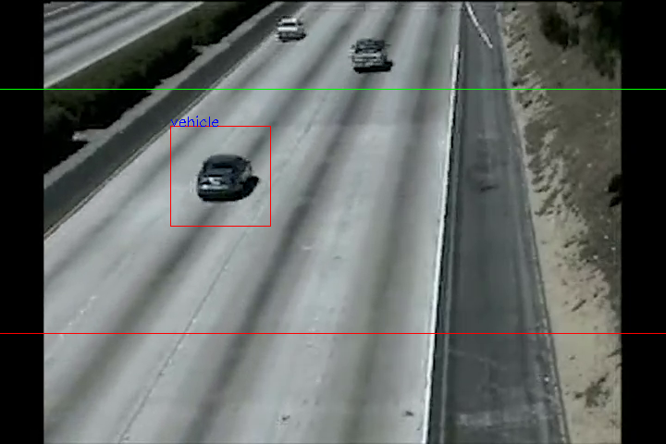

Figure : Vehicle detection using Haar-cascades

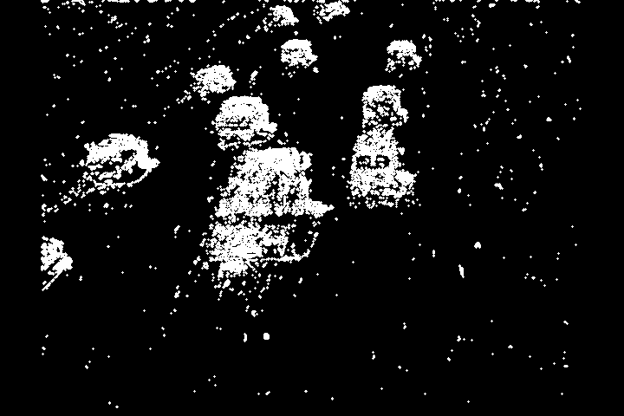

Figure : vehicle detection by background subtraction

|  |  |  |
| --- | --- | --- |
| Total vehicles = 70 | Haar-cascade | Background Subtraction |
| False positives | 9 | 17 |
| True positives | 70 | 70 |

# Conclusions & Future Work

using a better trained cascade-classifier can improve accuracy.

Noise reduction techniques in case of background subtraction.

Implementation is easy as cams are already available at intersections in US;

Future work: speeding, and vehicle/numberplate recognition;

1. <http://www.latimes.com/business/autos/la-fi-hy-ihs-automotive-average-age-car-20140609-story.html>
2. <https://mobility.tamu.edu/ums/media-information/press-release/>
3. S. G. Shelby. Single-intersection evaluation of real-time adaptive traffic signal control algorithms. Transportation Research Record, 1867:183–192, 2004. <https://doi.org/10.3141/1867-21>